Interior Renovations – Sample Plans FAQ
This handout is intended only as a guide. While every attempt has been made to insure the correctness of this handout, no guarantees are made to its accuracy or completeness. Responsibility for compliance with applicable codes and ordinances falls on the owner or contractor.
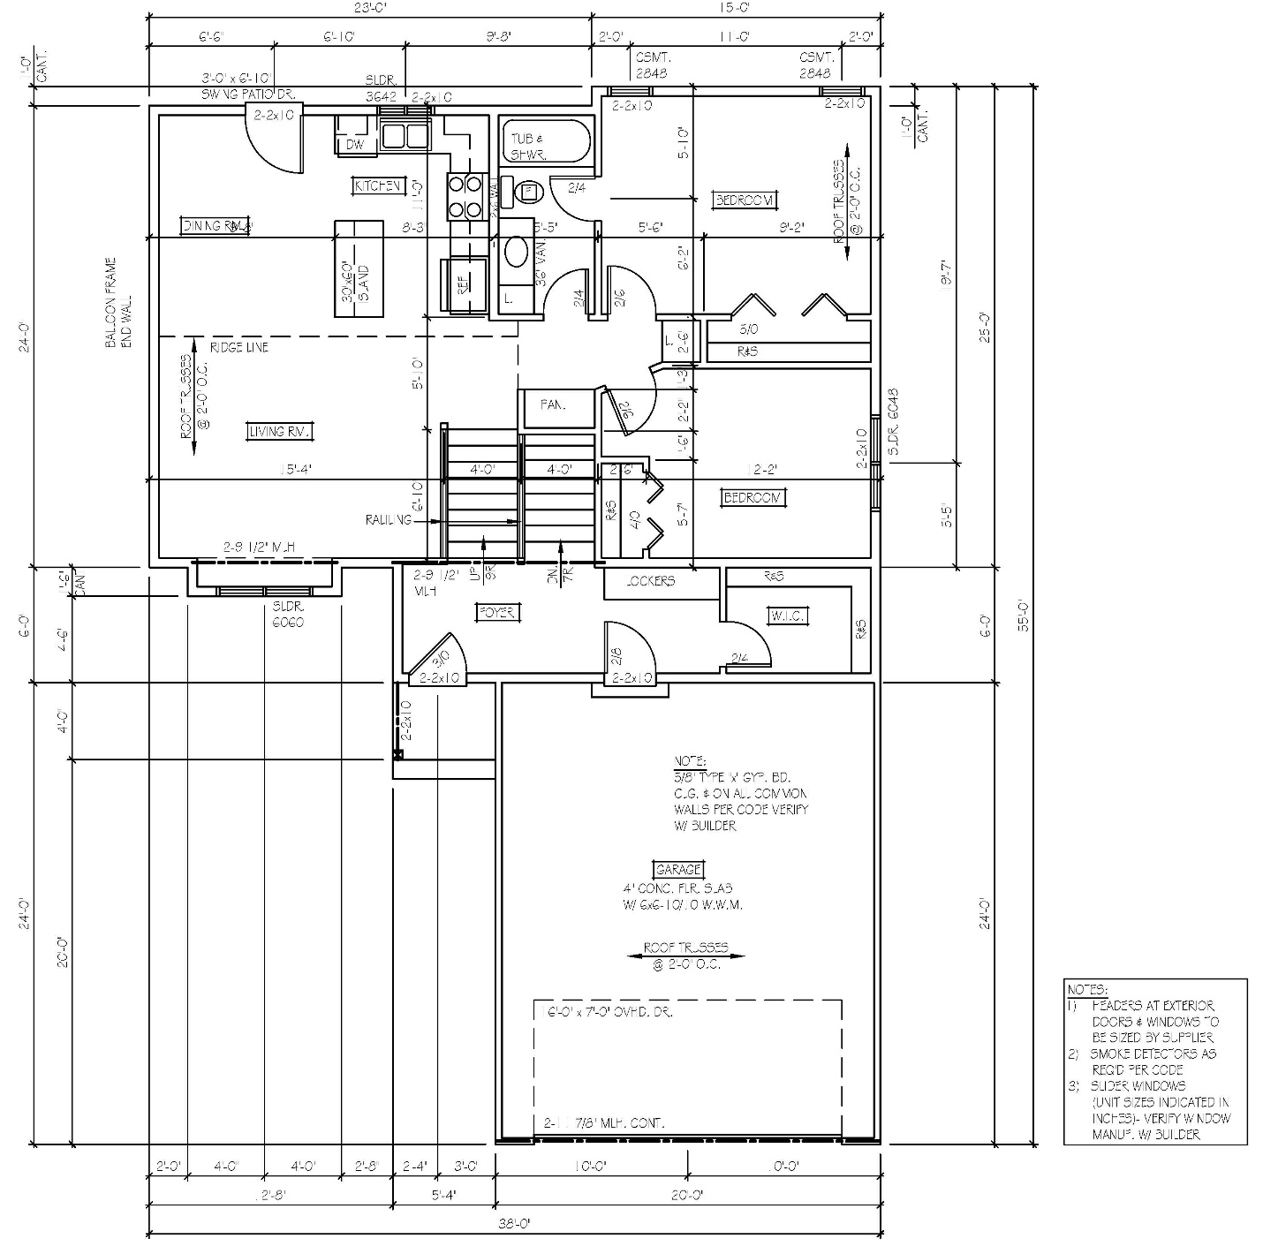
Plans do not need to be professionally, or computer drawn (though recommended), but MUST be drawn to scale. The following drawing does not show all requirements for building plans. Consult with the Building Inspector or Contractor before submitting to make sure you have shown all requirements.

